|  |  |  |
| --- | --- | --- |
| **Clue** | **Year** | **Possible Serial No** |
| Burned in “L10” / “R10” in Action board and Reedpan blocks  10 is probably the last two digits of the Serial No.  <http://www.concertina.net/forums/index.php?showtopic=18392> |  | XXX10 |
| Riveted reeds, Edward Childey period  22002 is known to be screwed reed (as are 22961 and 23235). It has an 1895 inscription, which is reasonable as its approximate date.  <http://www.concertina.net/forums/index.php?showtopic=5733> | 1865-1895 | 18000-22001 |
| Serial No between 18000 and 21000  Source:  <http://www.concertina.net/forums/index.php?showtopic=18392> |  | 18000-21000 |
| Riveted levers, Edward Childey,    Wheatstone earliest known Serial No 19870 from 1880  Source:  RE. Actions thinking inside the box  on 26 Jan 2011 04:35 by Chris Flint (version 1) 8732K | 1880 -1895 | 19910- 21310 |
| ~~19910 Rosewood Steel~~  ~~20010 Walnut 2~~~~nd~~ ~~class~~  20110 Rosewood polished 48 /1882  ~~20210 Baritone~~  ~~20310 Ebony~~  20410 No 5 Rosewood 48 /1885  ~~20510 Walnut~~  ~~20610 Walnut~~  ~~20710 Walnut~~  ~~20810 Walnut~~  ~~20910 Walnut~~  ~~21010 Aeola~~  21110 No 4 Rosewood / 1890 (24Key?)  21210 No 2 Rosewood / 1891 (22 Key?)  ~~21310 Walnut~~ |  |  |

**[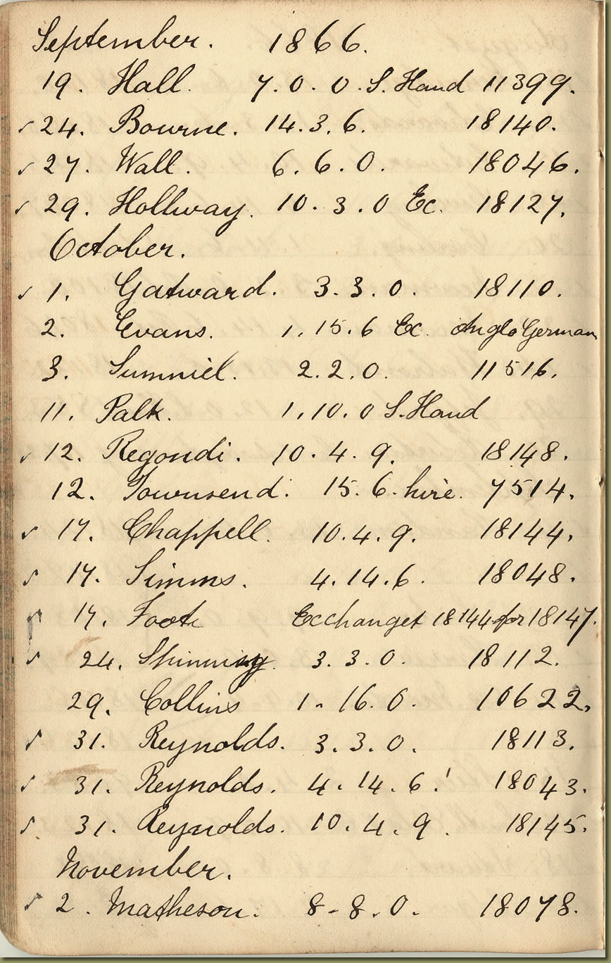](http://www.horniman.info/WNCMARC/C1053/PAGES/C9P0280S.HTM)**

**[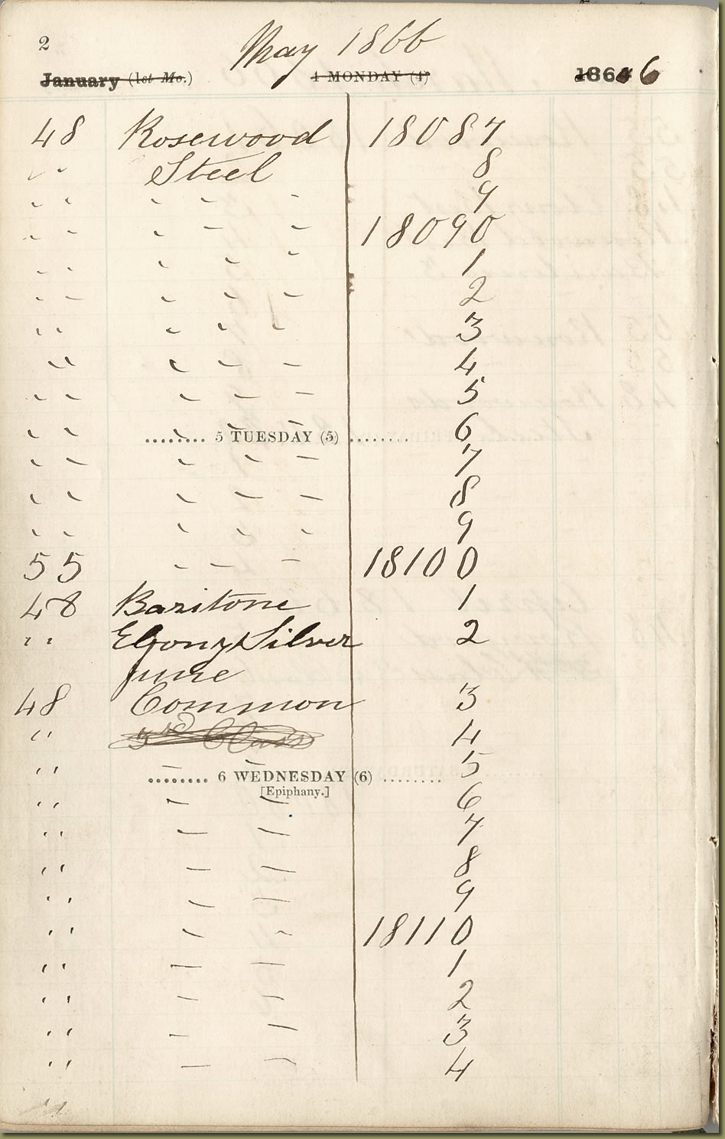](http://www.horniman.info/WNCMARC/C1054/PAGES/CAP1340S.HTM)**

**[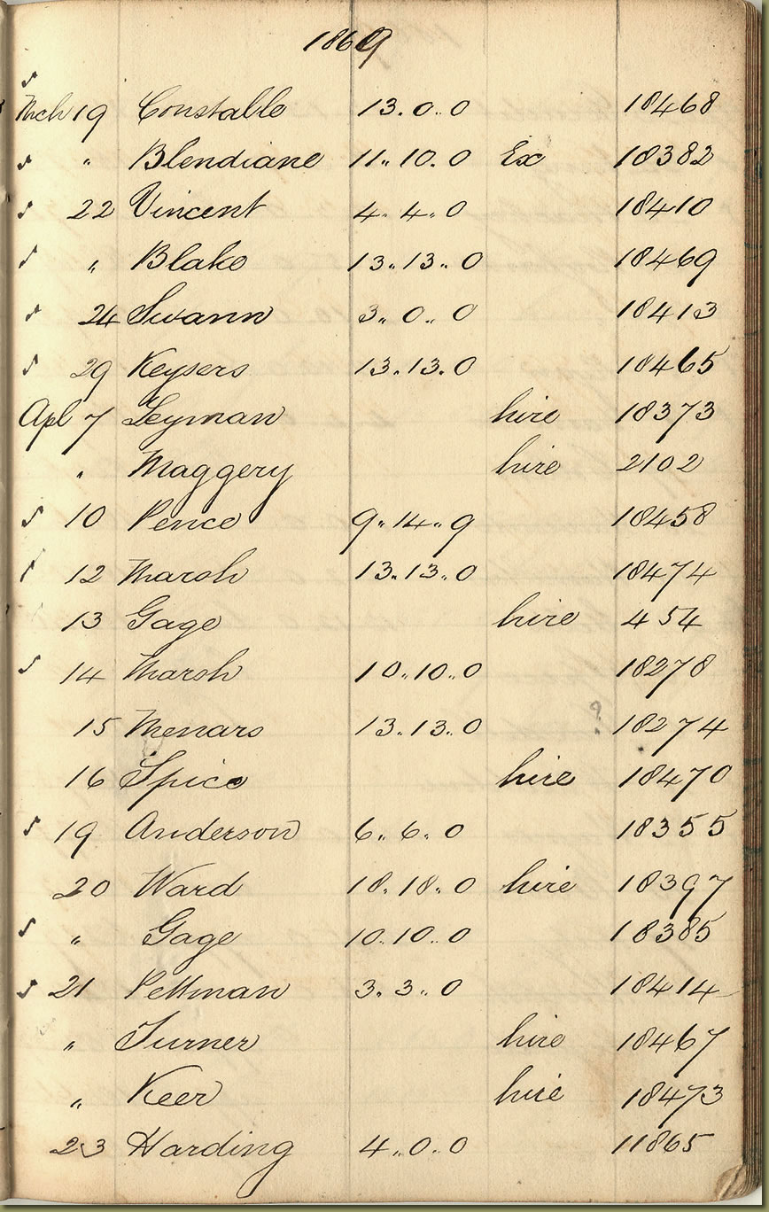](http://www.horniman.info/WNCMARC/C1053/PAGES/C9P0530S.HTM)**

**[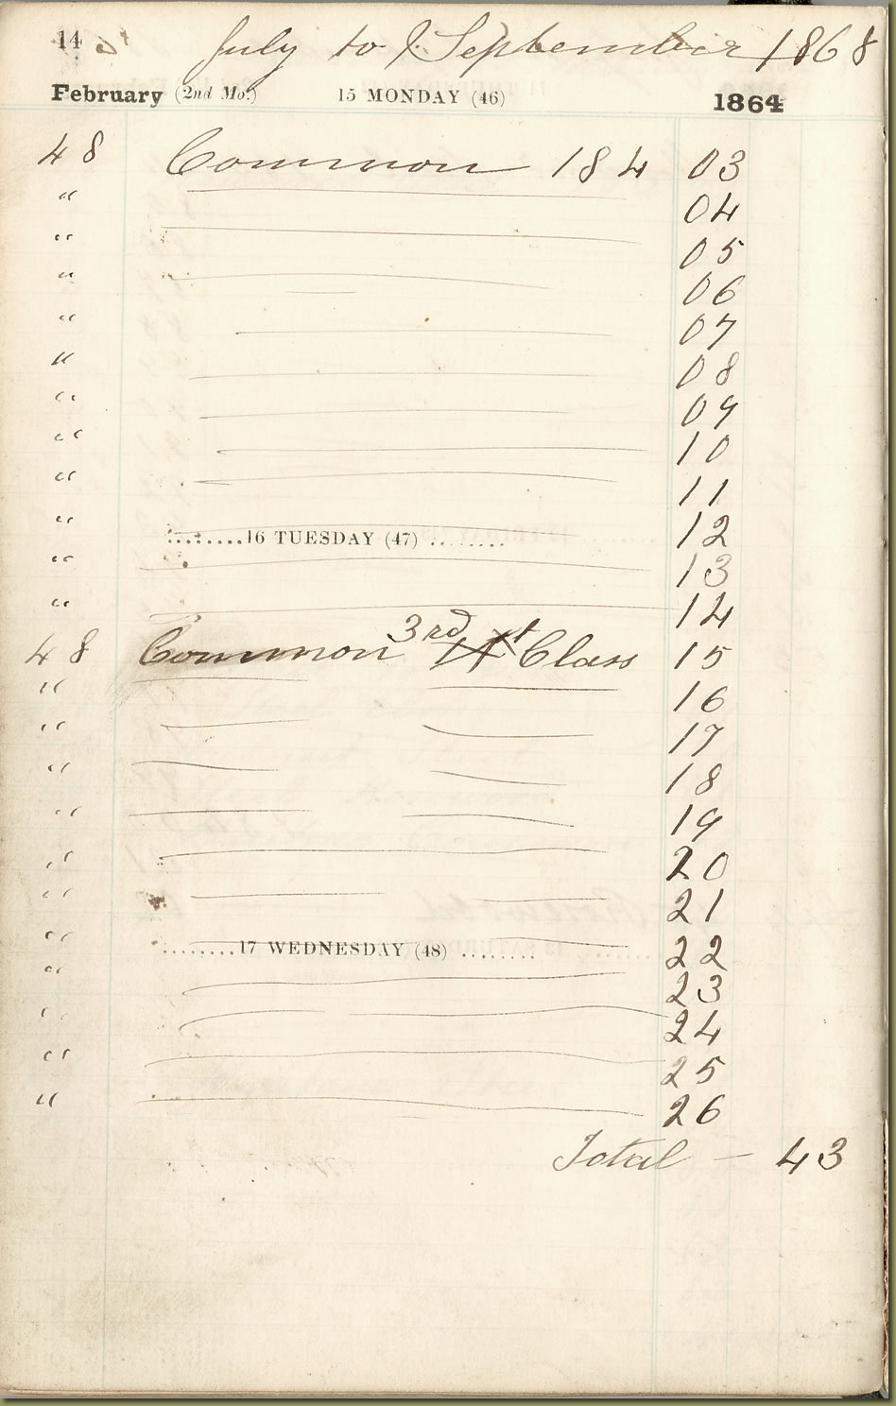](http://www.horniman.info/WNCMARC/C1054/PAGES/CAP1460S.HTM)**

**[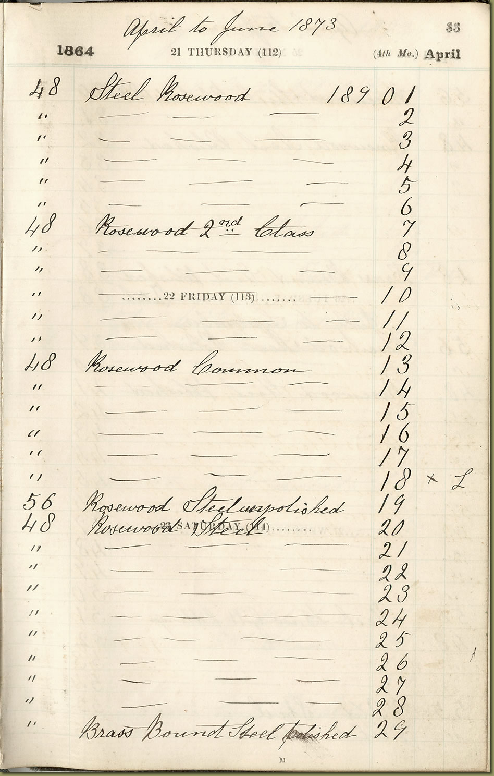](http://www.horniman.info/WNCMARC/C1054/PAGES/CAP1650S.HTM)**

**[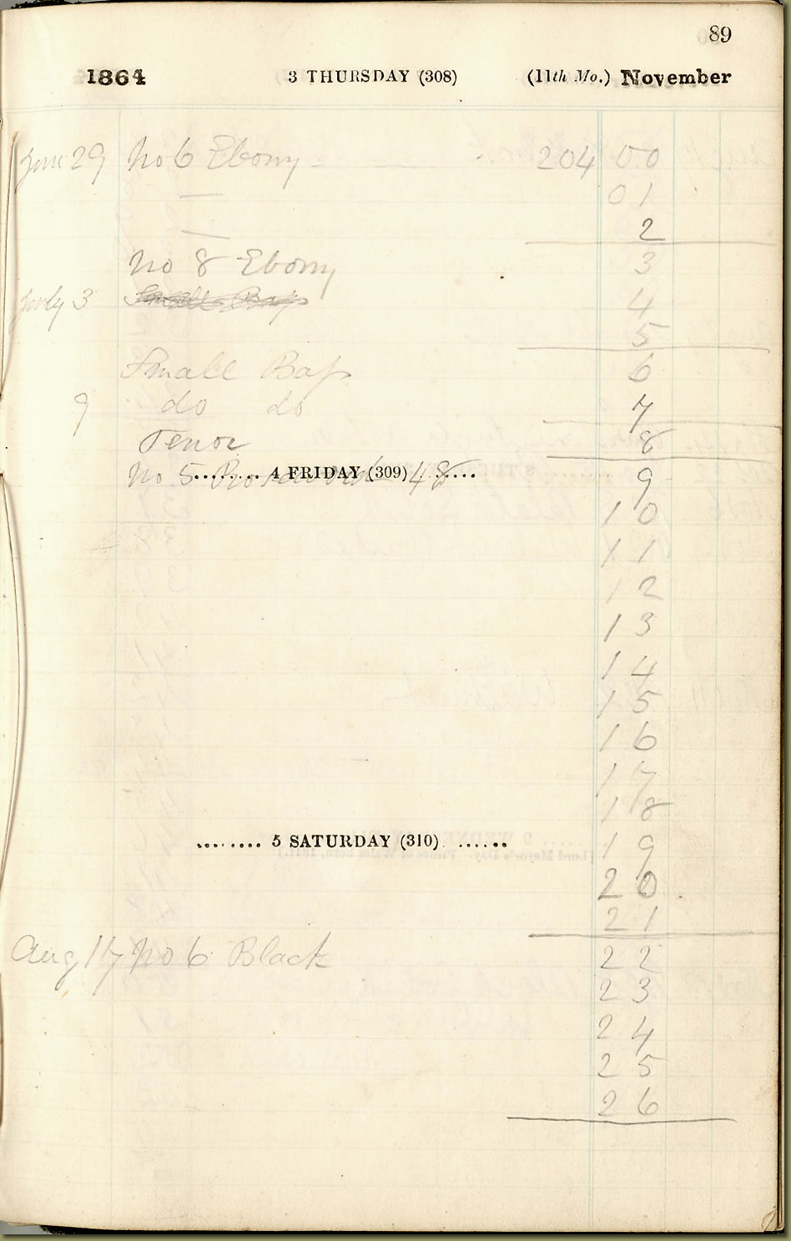](http://www.horniman.info/WNCMARC/C1054/PAGES/CAP2210S.HTM)**

**[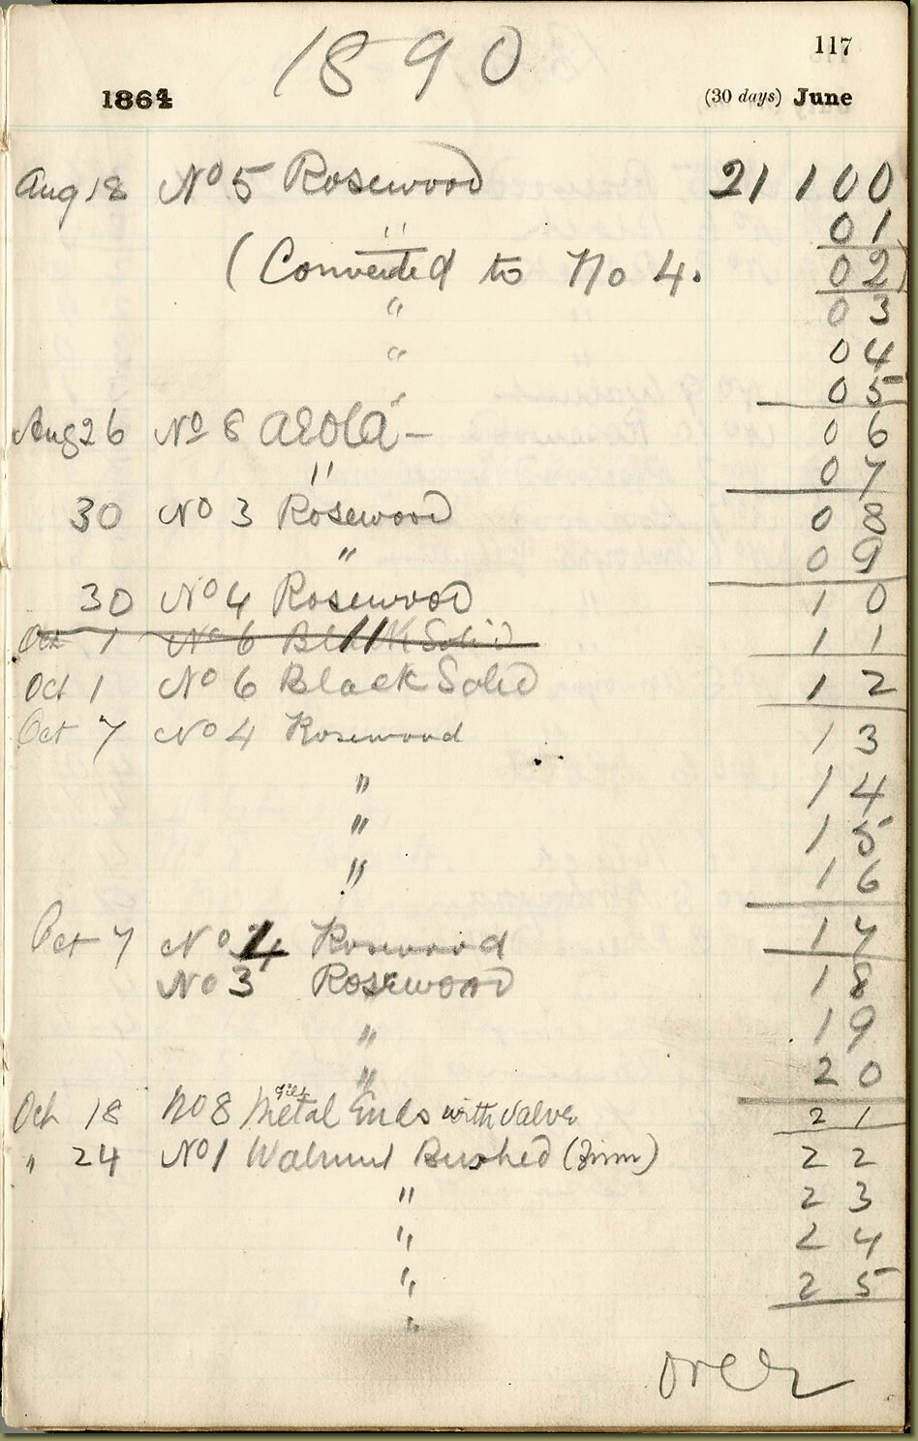](http://www.horniman.info/WNCMARC/C1054/PAGES/CAP2490S.HTM)**

**[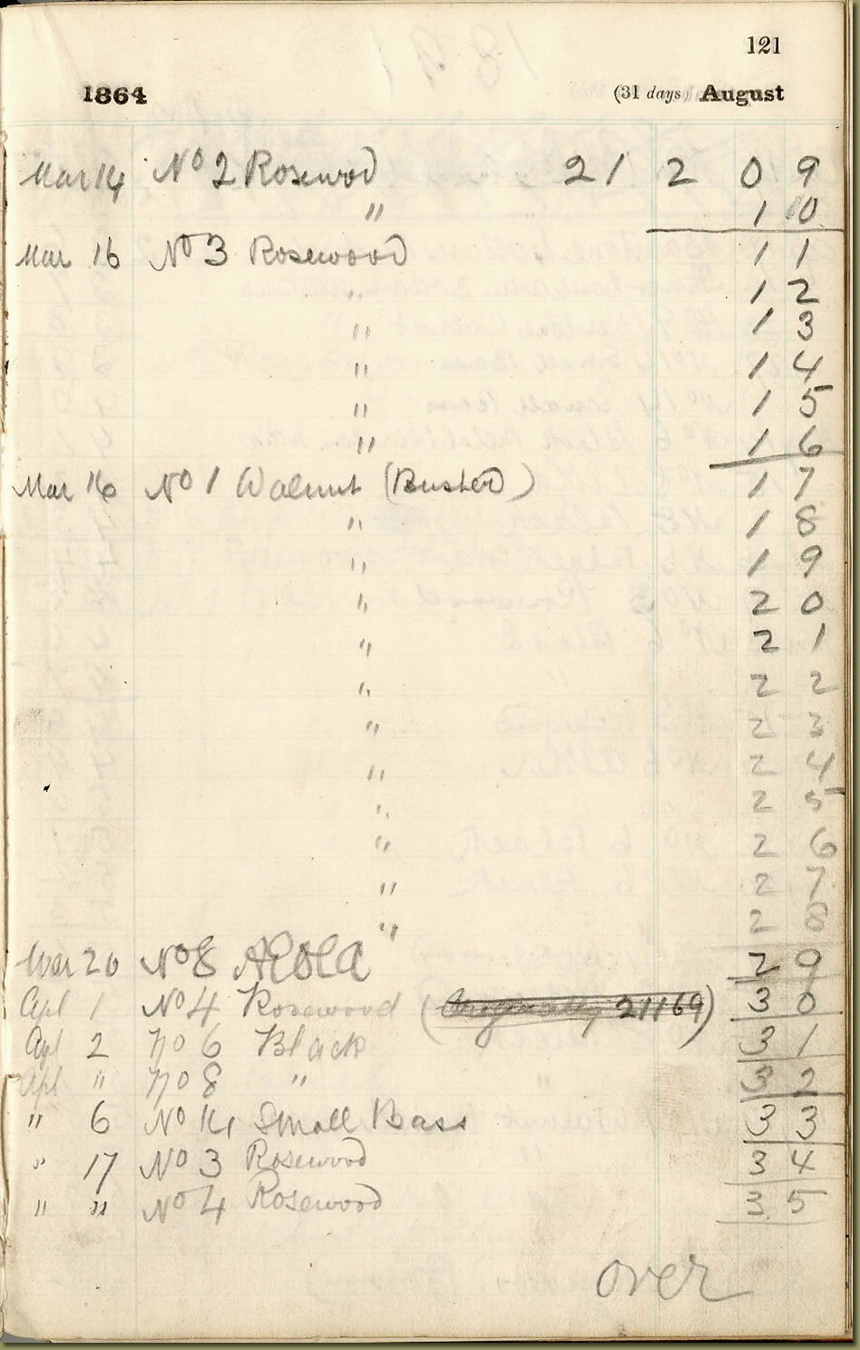](http://www.horniman.info/WNCMARC/C1054/PAGES/CAP2530S.HTM)**

